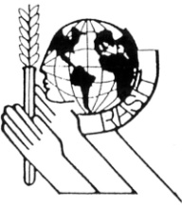
PRESS OFFICE
www.rasit.org
Contact: RASIT Press Office
info@rasit.org
Baghdad 24th September 2009
FOR IMMEDIATE RELEASE

RASIT’s Executive Director Distributes School Bags to Underprivileged Students in Baghdad

The Royal Academy of Science International Trust (RASIT) continues its humanitarian efforts to help underprivileged Children in Iraq through the programs of El-Sharifa Fatima Fund.  In a gesture of support for the Iraqi children, the Executive Director of RASIT,HRH Princess Dr Nisreen El-Hashemite visited underprivileged families in various parts of Baghdad, and distributed 2500 school bags to children aged between 6 - 10 years. Every school bag contains all the required materials and books for the school year. | 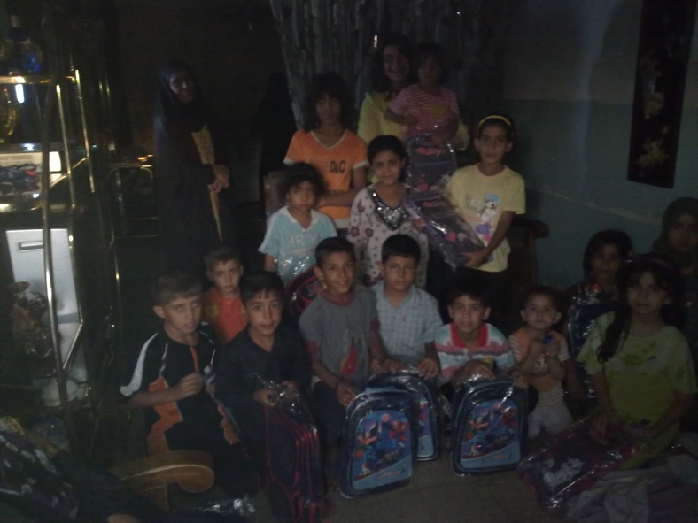

Princess Dr Nisreen El-Hashemite - The Executive Director of RASIT, and during her field trips to various provinces in Iraq said: “economic and social factors of the Iraqi family have a significant impact on children and schooling. Many families can not provide the most basic needs for their children such as school bags, books, notebooks and pens… A large number of children working to help their families. " Dr El-Hashemite continues: "Also the security situation and the transportation to and from school is one of the important problems facing children in Iraq.. many of the children walk long distances on foot to get to school.. this is in addition that most of the schools need rehabilitation of both buildings and services such as water, electricity and sanitation facilities, furniture and classrooms. There is also a shortage of teaching materials such as school books and tools necessary including the special classes for practical and scientific education and libraries. The situation in the villages and provinces is worse than Baghdad”.
Princess Dr Nisreen El-Hashemite stressed on the need to take an urgent action to promote and encourage the enrollment of children in schools. This has to include providing transportation to schools and improve the level and quality of education through improving educational curricula and the provision of textbooks and accessories, and rehabilitation of school buildings and public facilities with an emphasis on children’s health, including psychological and physical health. A moral support in Iraq is very essential to encourage families enroll their children in schools. | 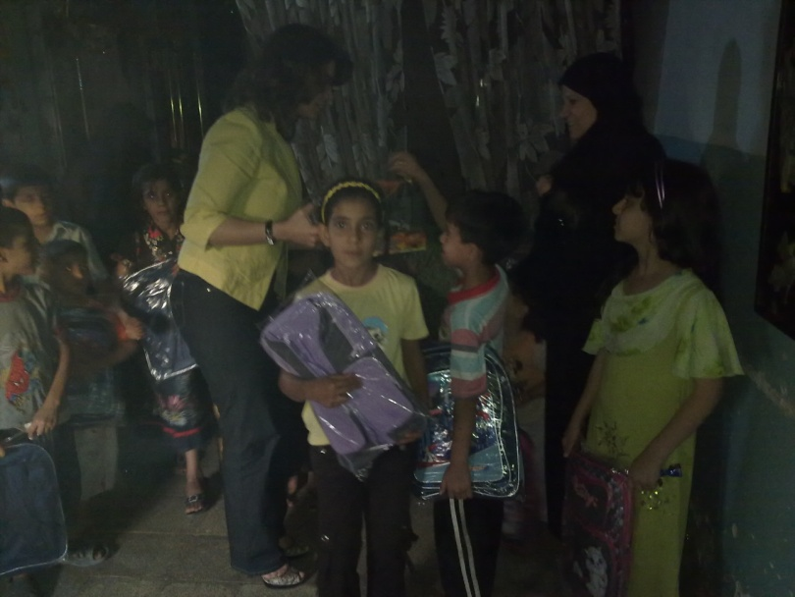

Before 1991, the education system in Iraq before 1991, was one of the best systems in the region where the enrollment rate among children in primary education was 100%, and the proportion of illiteracy among men and women was the least in the region. However, since the Gulf War in 1991 and the subsequent economic sanctions that put Iraq in isolation from the outside world, which was followed by the 2003 war, and the subsequent instability in Iraq due to terrorism and killing of civilians, the number of widows and orphans and the underprivileged people has increased dramatically, leading to a significant decrease in the percentage of Iraqi children enrolled in school. According to UNESCO reports less than 40% of Iraqi children join schools.

The Royal Academy of Science International Trust (RASIT) is an international non-governmental organization serving education and humanity since 1969.

For more information on RASIT’s humanitarian efforts for Iraq, please contact Ms Nora Mehdi on info@rasit.org

